EXPERIMENTNO14

DeterminationandplottingofPolarizationindifferentDielectric Medium with their relative permittivity and to find electric susceptibility.
Aim:
To determine and plot polarization in different dielectric medium with theirrelativepermittivityandtofindelectricsusceptibility.

Softwarerequired:
- SCILABversion6.0.1

Program:
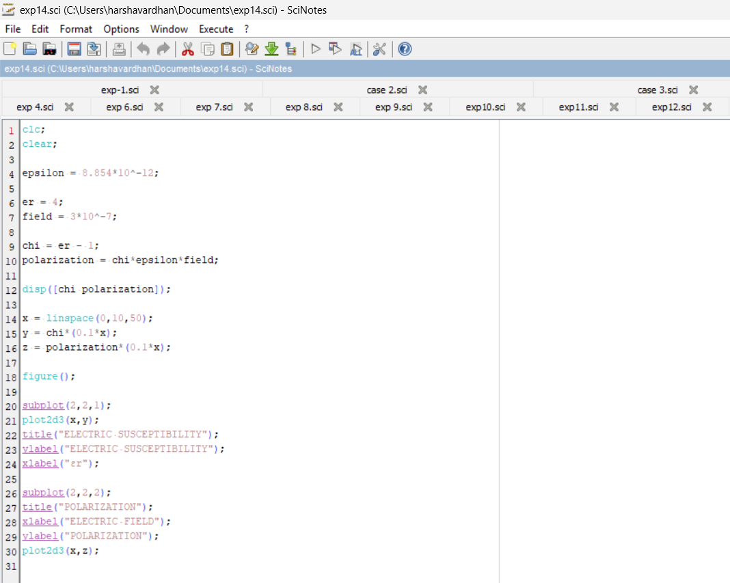

Output:

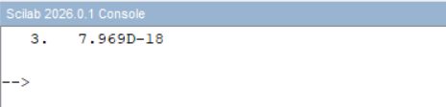

Theoreticalcalculations:
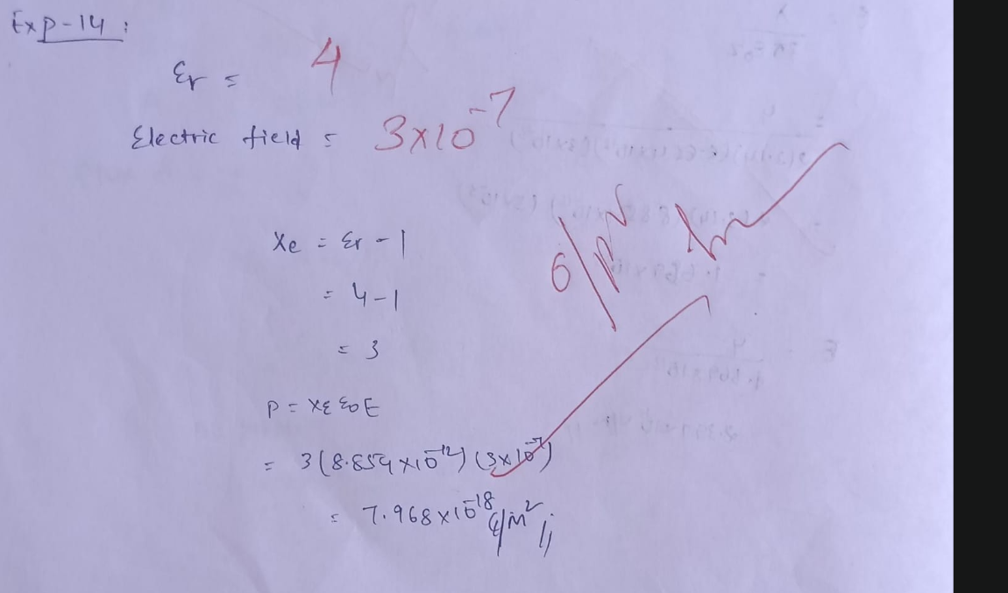

Case 1: To determine and plot the polarization and electric susceptibility of electromagnetic waves in three dielectric media:Air,Water,andGlass,usingtheirrelativepermittivity.
Program:
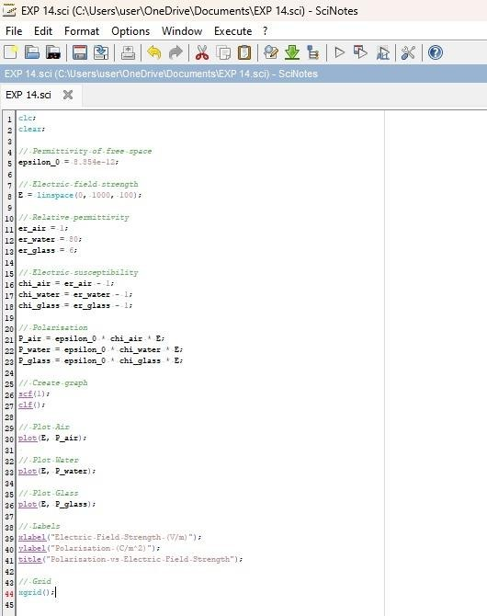

Output:
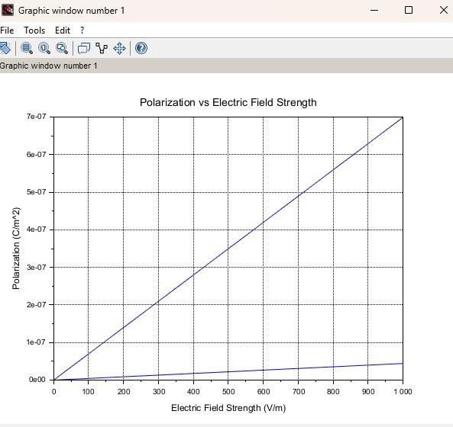
Case 2: To calculate and plot the polarization and electric susceptibility in Silicon, Teflon, and Paper, and understand how their relativepermittivityaffectsthepolarization.

Program:
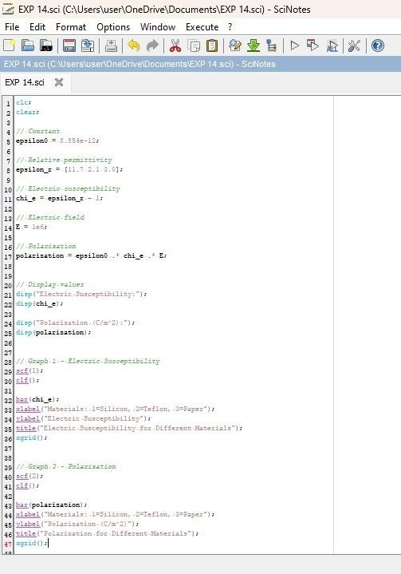

Output:
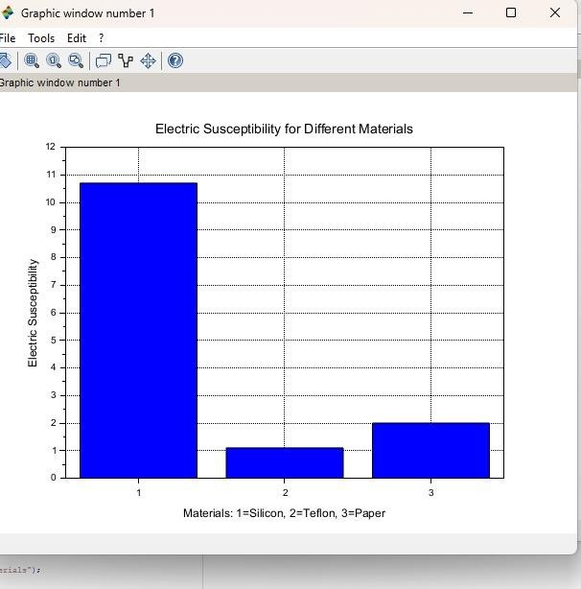
Case 3: To explore how different dielectric materials (Rubber, Oil, and Plastic)affectthepolarizationand electricsusceptibility,andto comparetheirrelativepermitivity.

Program:
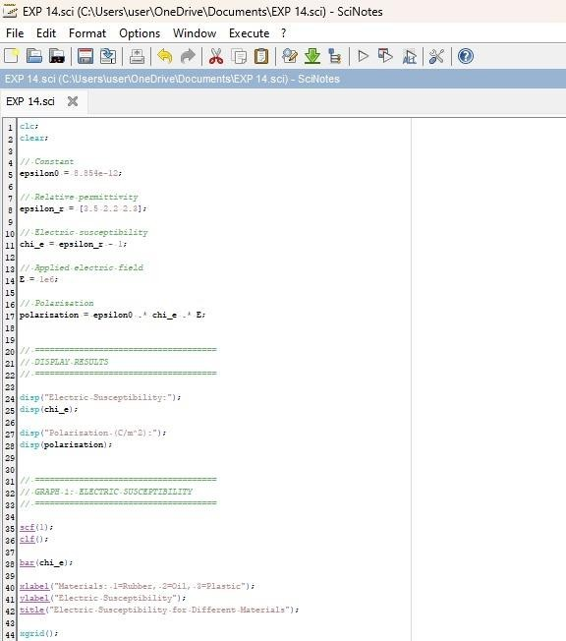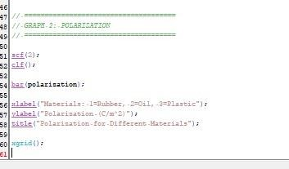

Output:
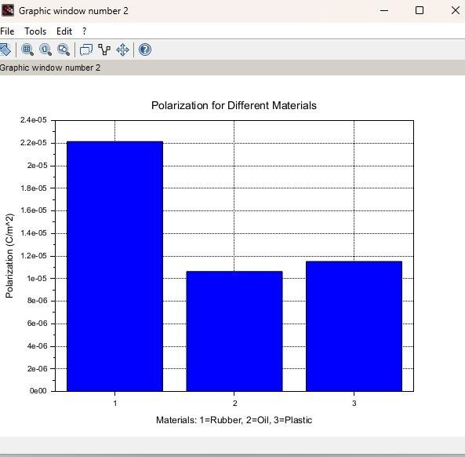

Case1:Examinetheeffectoflengthofaferromagneticmaterialon themagneticfluxdensity(B)forthe
followingconditions



The material is ferromagnetic with relative permeability (μr) of 500. Themagneticfieldintensity(H)isheldconstantat100A/m.
Thelengthofthematerialvariesfrom0.1mto2m.

Program:

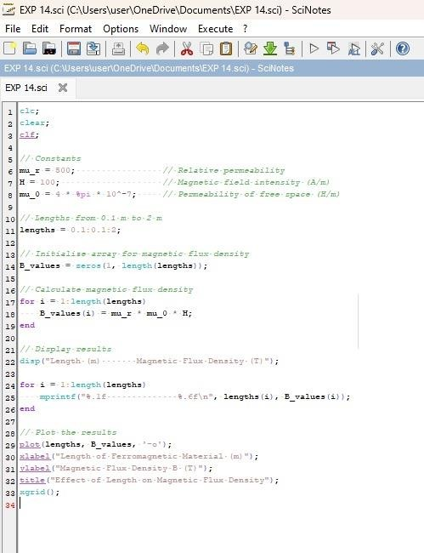

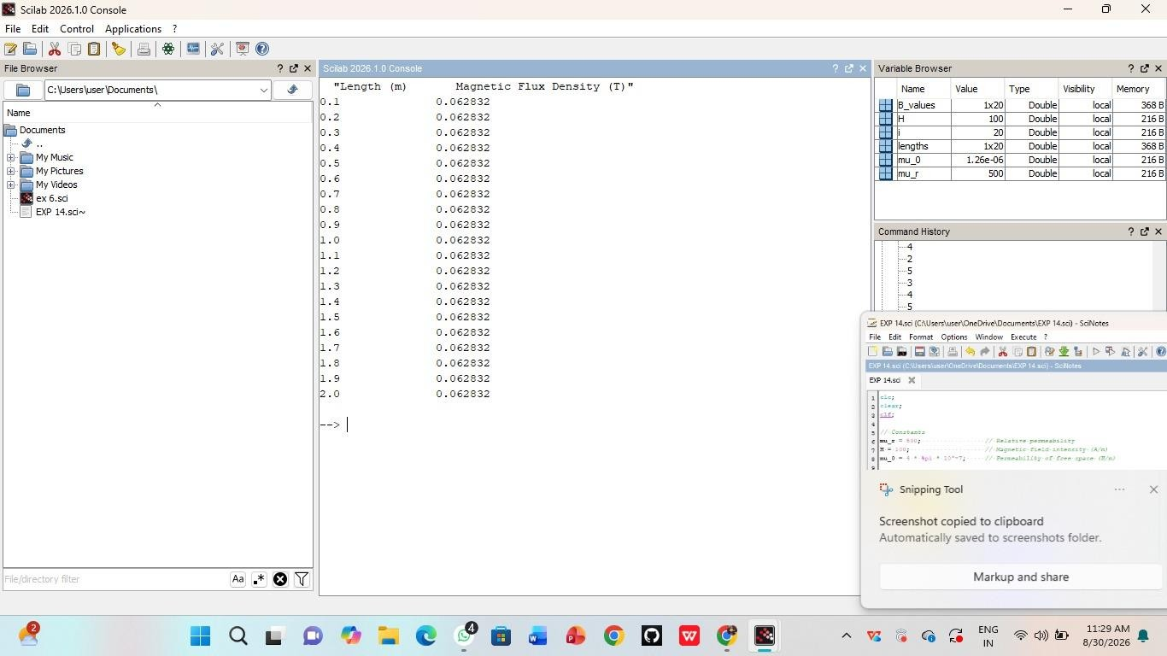
Output:
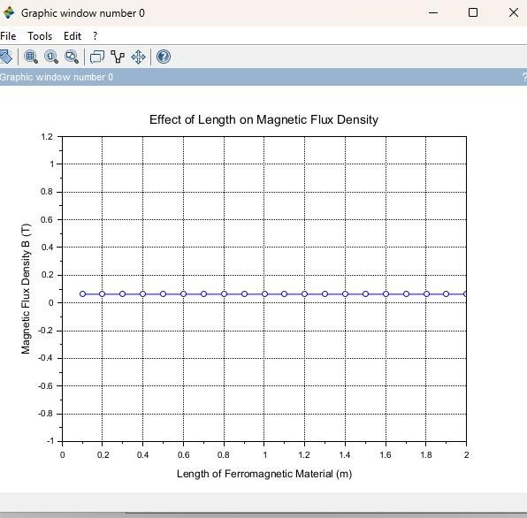

Case2:Toinvestigatehowthemagneticfluxdensity(B)ina ferromagneticmaterialchangeswith
differentwidthsataconstantlengthandmagneticfieldintensity. Conditions:
- Material:Softiron(sameasinCaseStudy1)
- Length(L):Constantat10cm
- MagneticFieldIntensity(H):Constantat1000A/m
- Width(W):Variesfrom2cmto10cm(i.e.,2cm,4cm,6cm,8cm,
10cm)

Program:
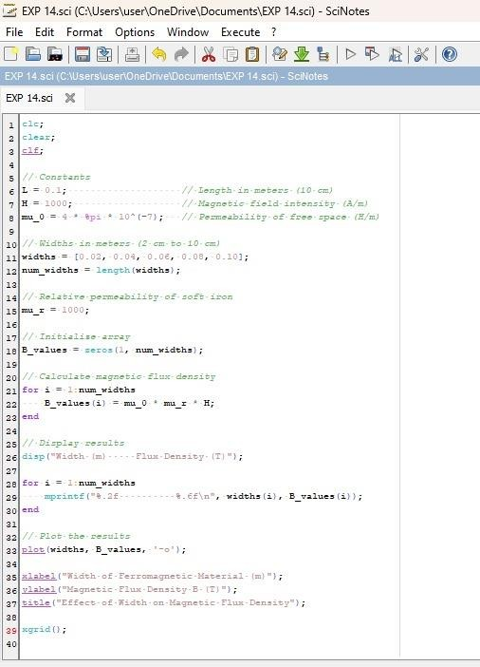

Output:

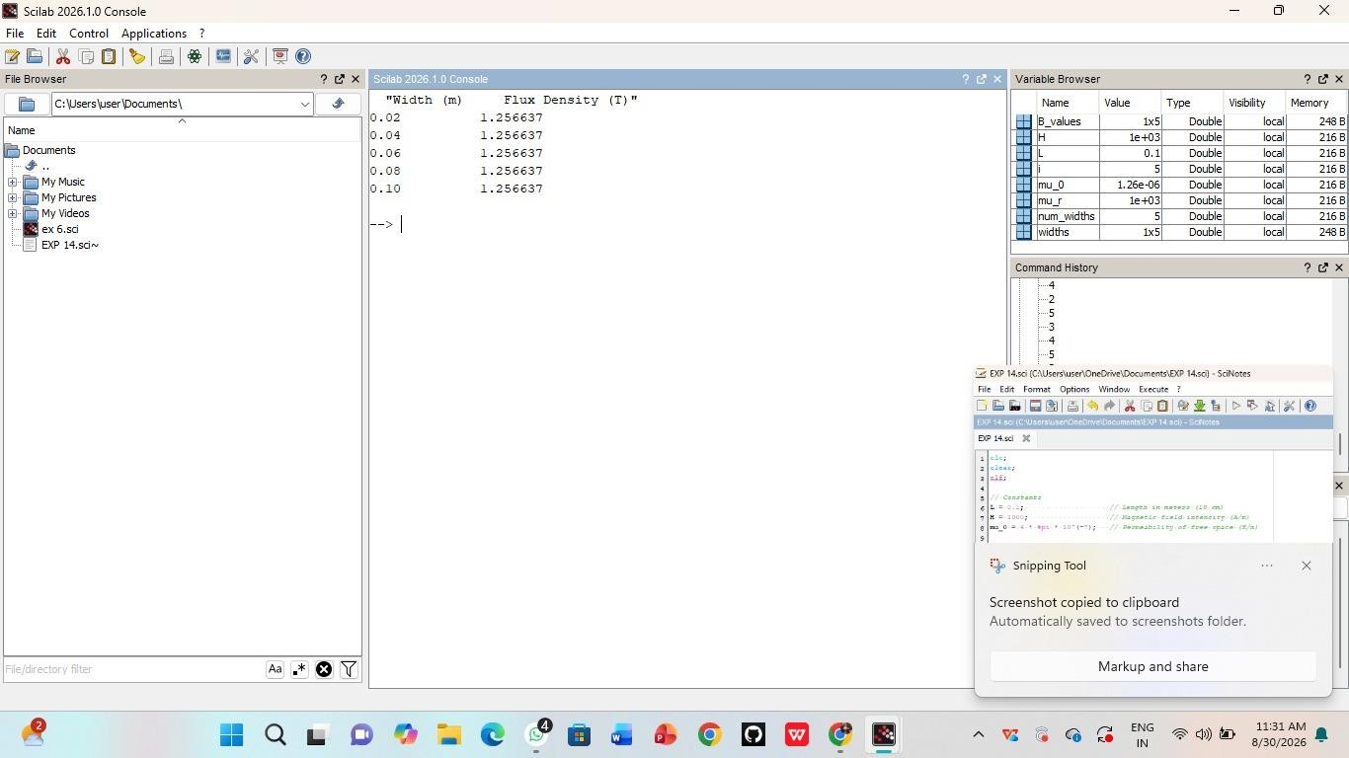
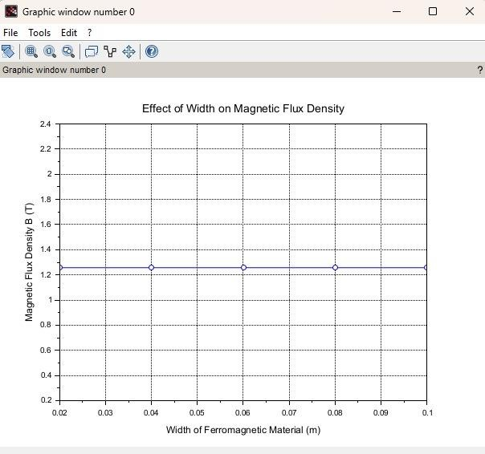

Case 3: To examine how the magnetic flux density (B) in a ferromagneticmaterialchangeswithdifferentvaluesofmagnetic fieldintensityatconstantlengthandwidth.
Conditions:
- Material:Softiron(sameasinthepreviousstudies)
- Length(L):Constantat10cm
- Width(W):Constantat5cm
- MagneticFieldIntensity(H):Variesfrom200A/mto2000A/m(i.e., 200A/m,500A/m,1000A/m,1500A/m,2000A/m)

Program:
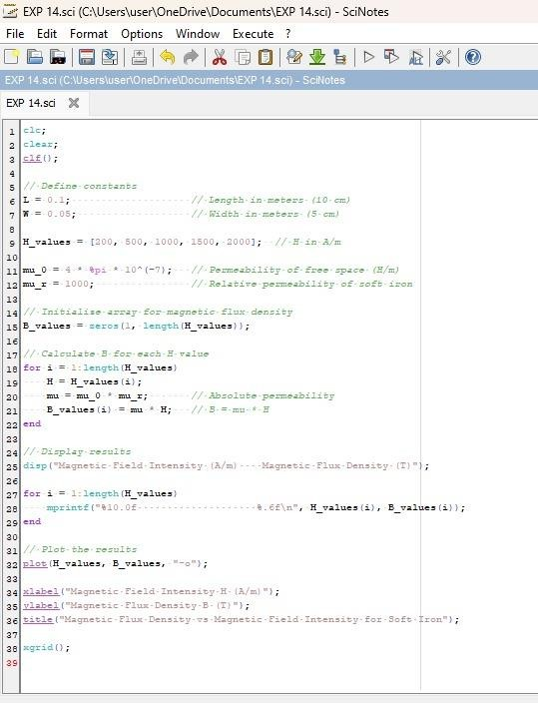

Output:
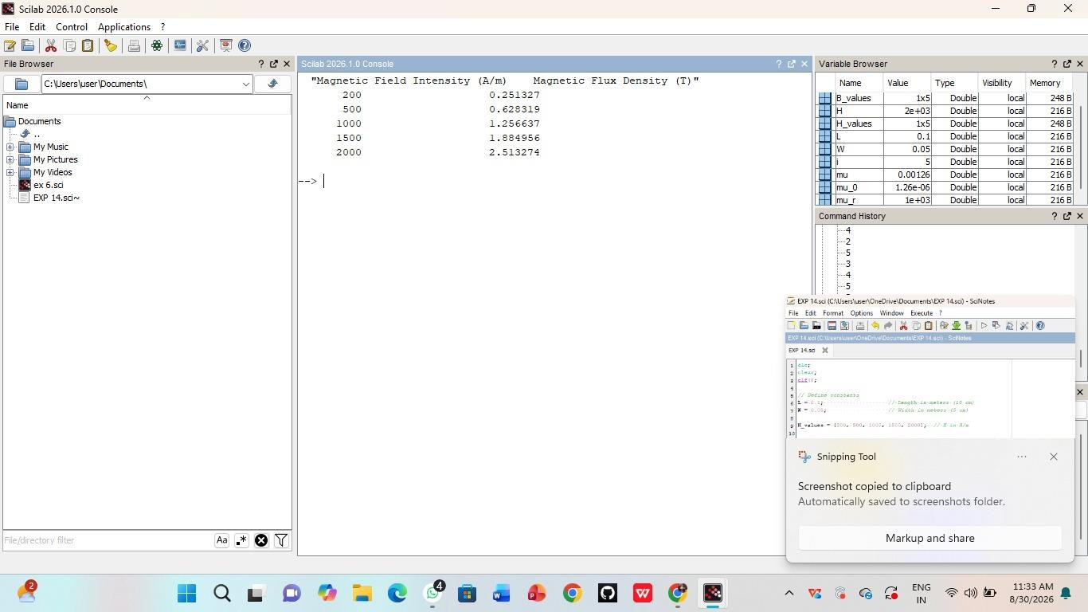

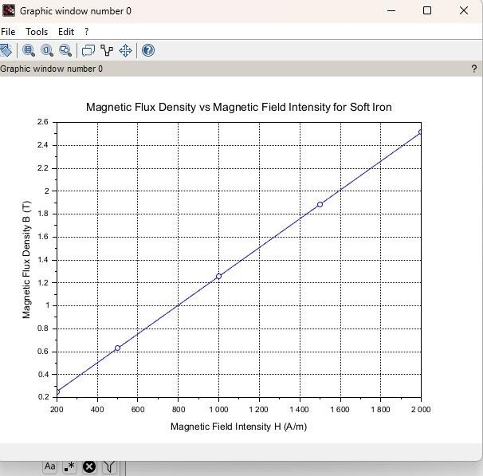

Result:ThustheprogramwasverifiedforprogramforMagneticflux densityinferromagneticmaterialsusingSCILABwassuccessfully.

